Join Midwest Aging Slack team: midwest-aging.slack.com

Slack is a software platform to exchange with each other. It is helpful for science, e.g.: http://www.nature.com/news/how-scientists-use-slack-1.21228

Registering an account
Go to midwest-aging.slack.com
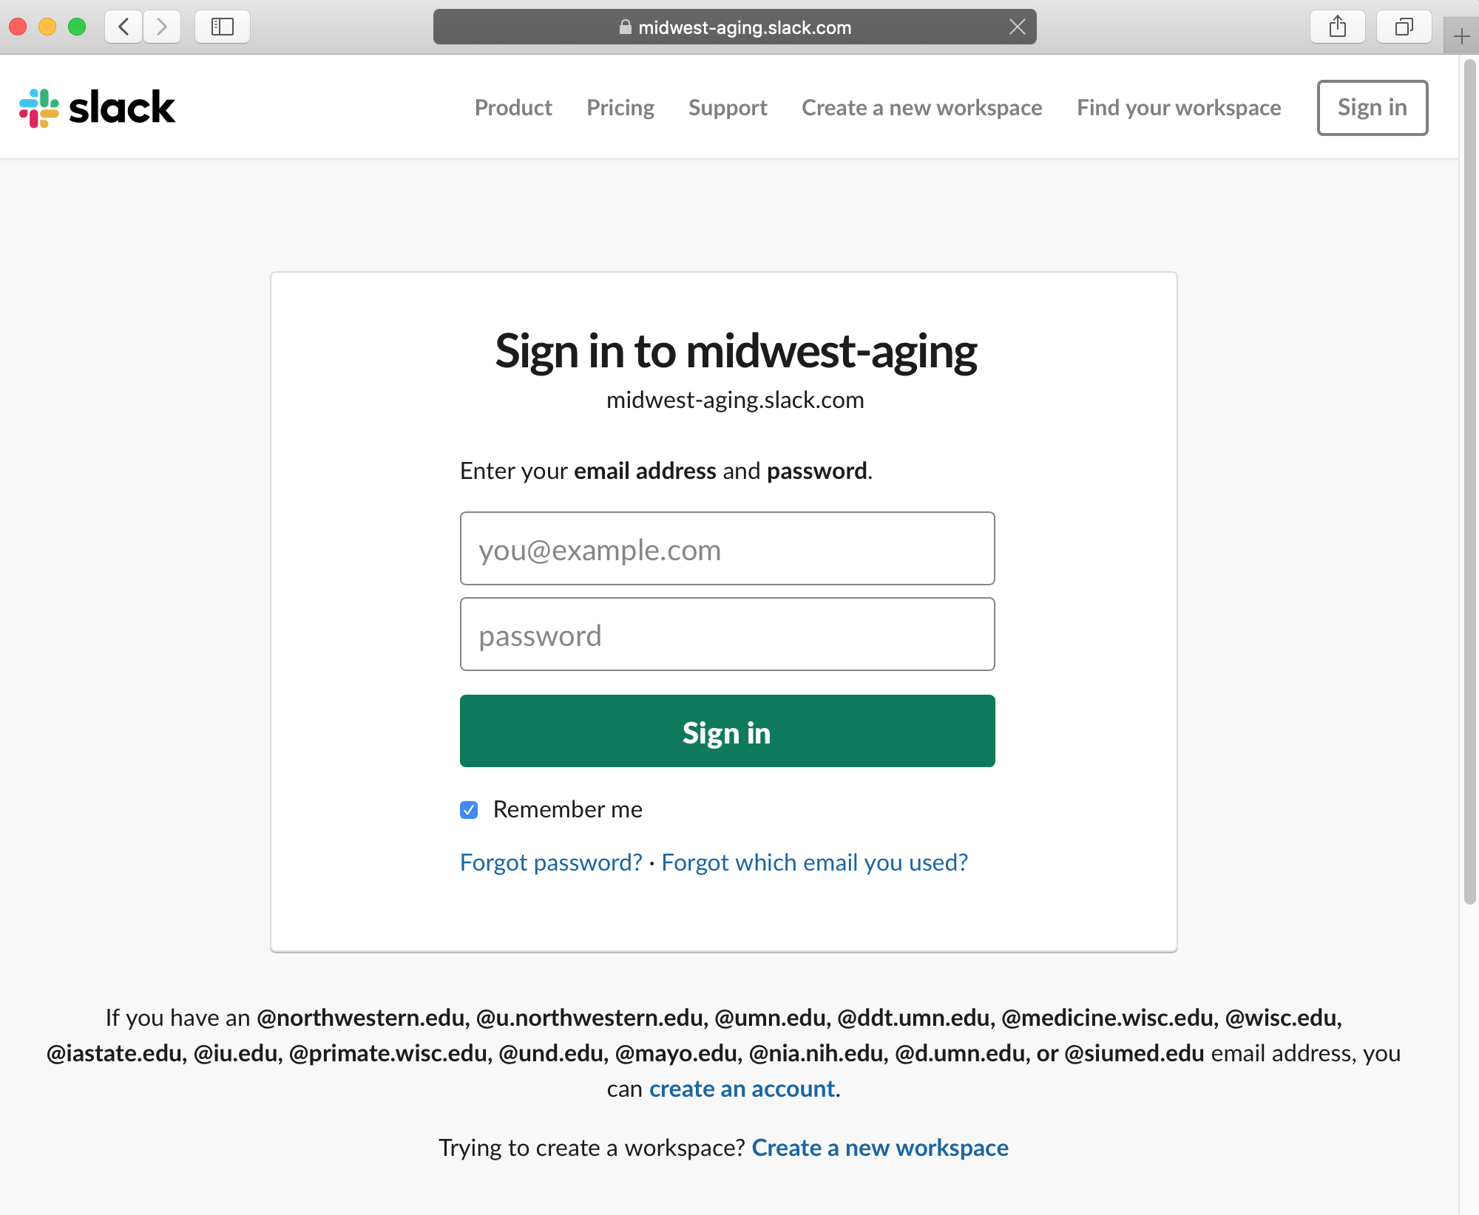
Prior using midwest-aging.slack.com for the first time you will need to register with the midwest-aging.slack.com Slack team. Note: distinct Slack teams will need separate Slack accounts. For instance, if you would already be using Slack for example-research-group.slack.com, you would still need to register for midwest-aging.slack.com.
To create an account for midwest-aging.slack.com click onto the “create an account” link in the bottom right corner of the screen.
Now create an account with your university email account e.g.: “u.northwestern.edu” or “medicine.wisc.edu”. If you do not have an university email account, or the email domain of your institute isn’t listed write a one- sentence mail to thomas.stoeger@northwestern.edu, and we will invite you to our Slack team.
Using the Midwest Aging Slack Team
Once you have registered an account, you will receive an email from Slack with further directions. Usually it contains a link that will allow you to log into Slack through your browser. However, there are also apps for smartphones, and for computers.

